[**Spring Data JPA with Hibernate**](https://github.com/seshadrimr/Digital-Nurture-4.0-JavaFSE/tree/main/Java%20FSE/Deepskilling/Spring%20Data%20JPA%20with%20Hibernate) **Outputs**

**Exercise 1: Employee Management System - Overview and Setup**

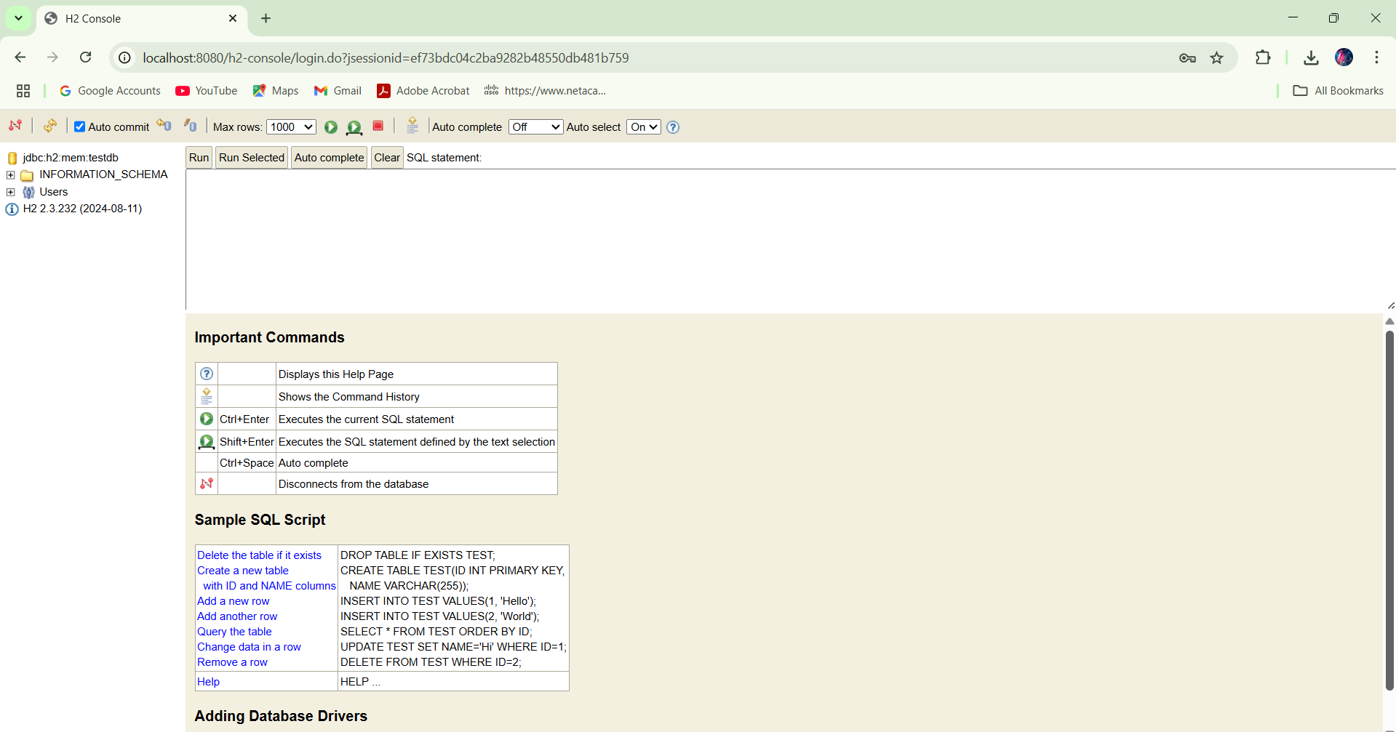

**Exercise 2: Employee Management System - Creating Entities**

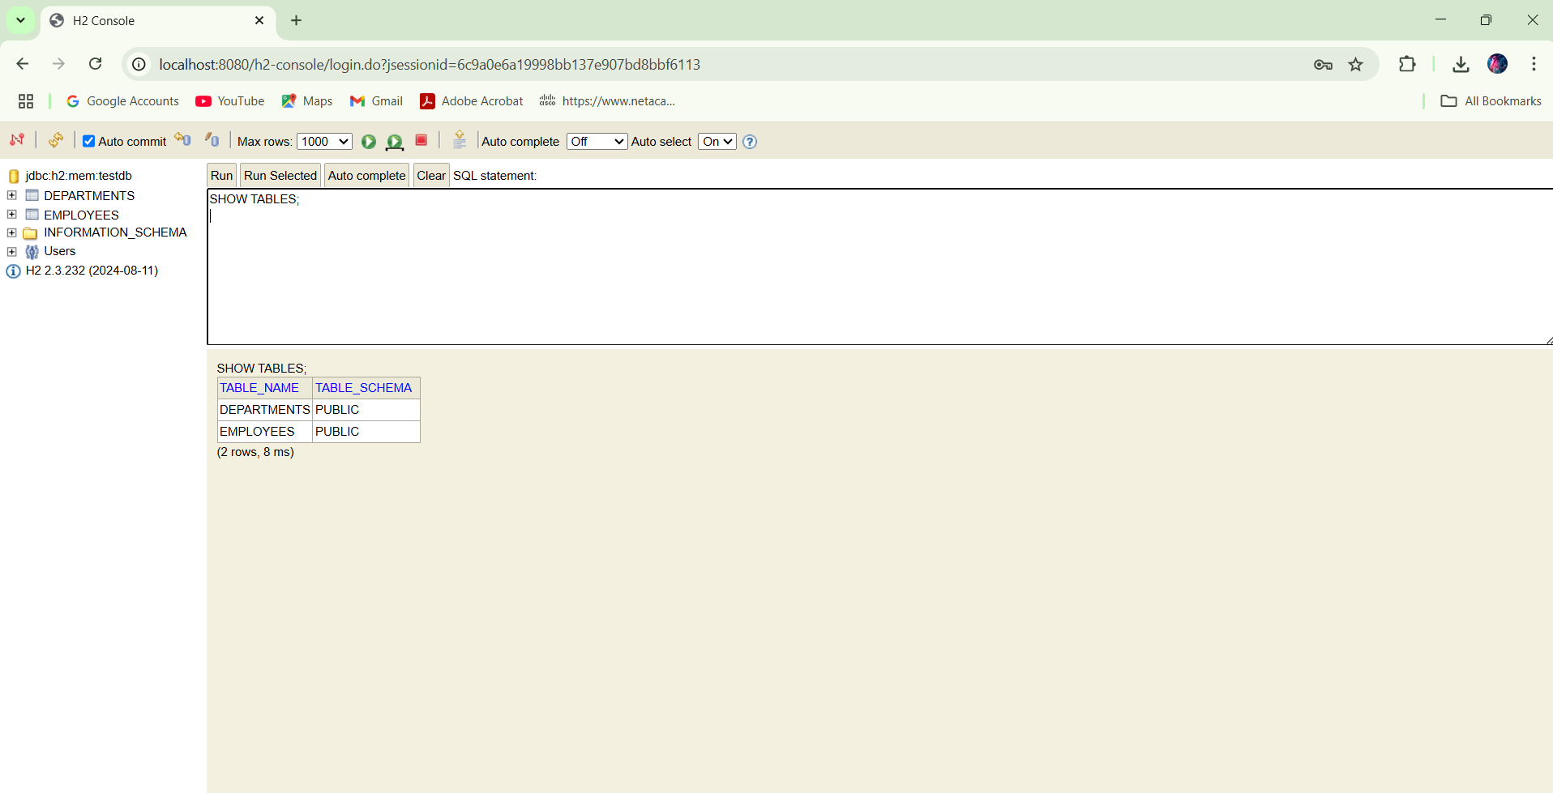

**Exercise 3: Employee Management System - Creating Repositories**

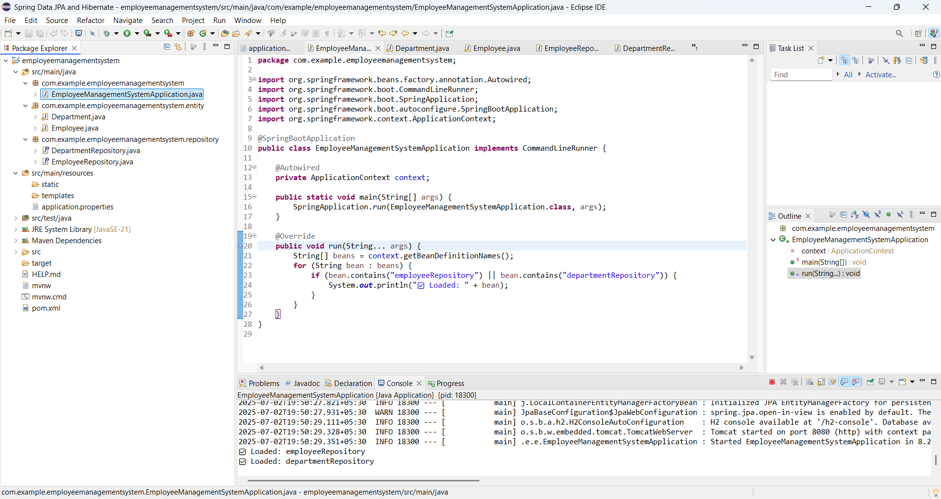

**Exercise 4: Employee Management System - Implementing CRUD Operations**

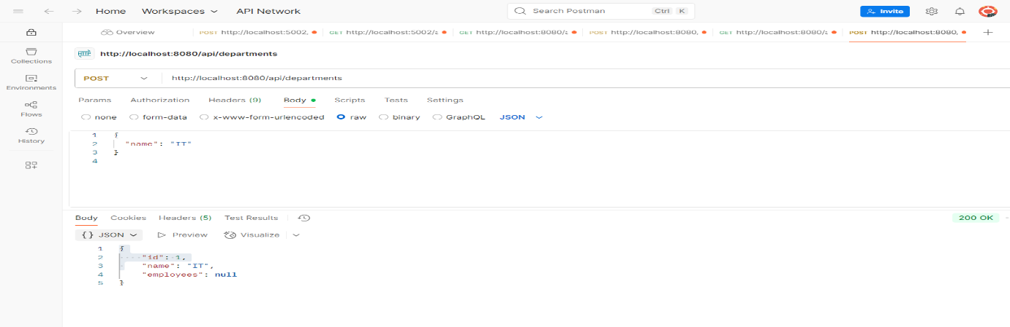

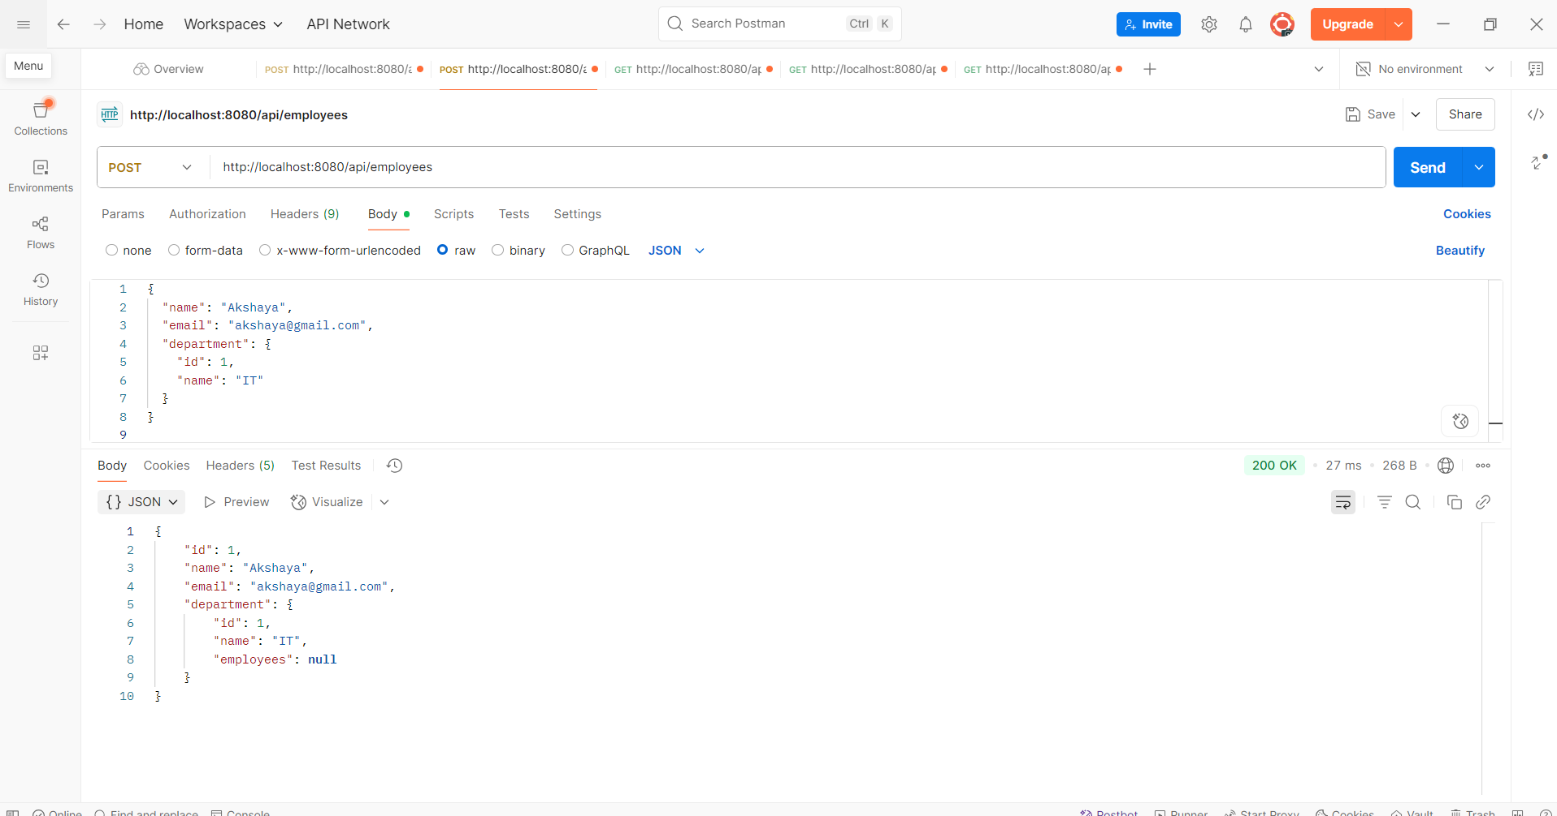

**Exercise 5: Employee Management System - Defining Query Methods**

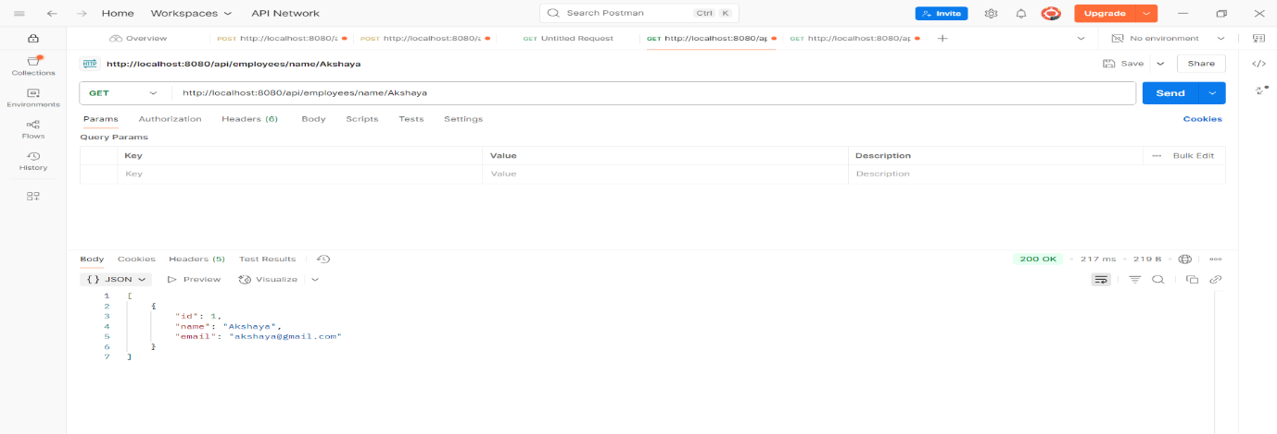

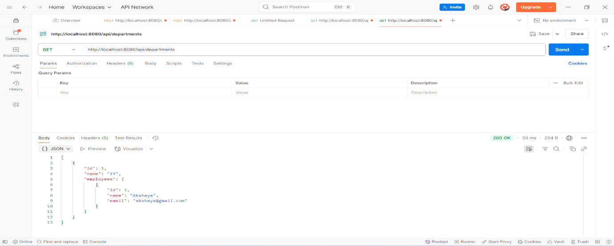

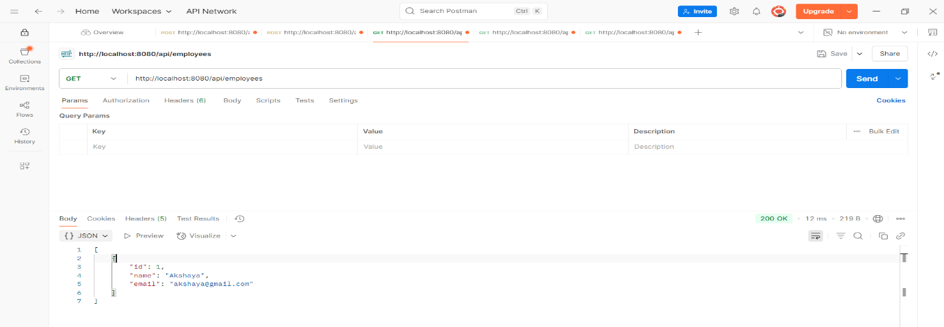

**Exercise 6: Employee Management System - Implementing Pagination and Sorting**

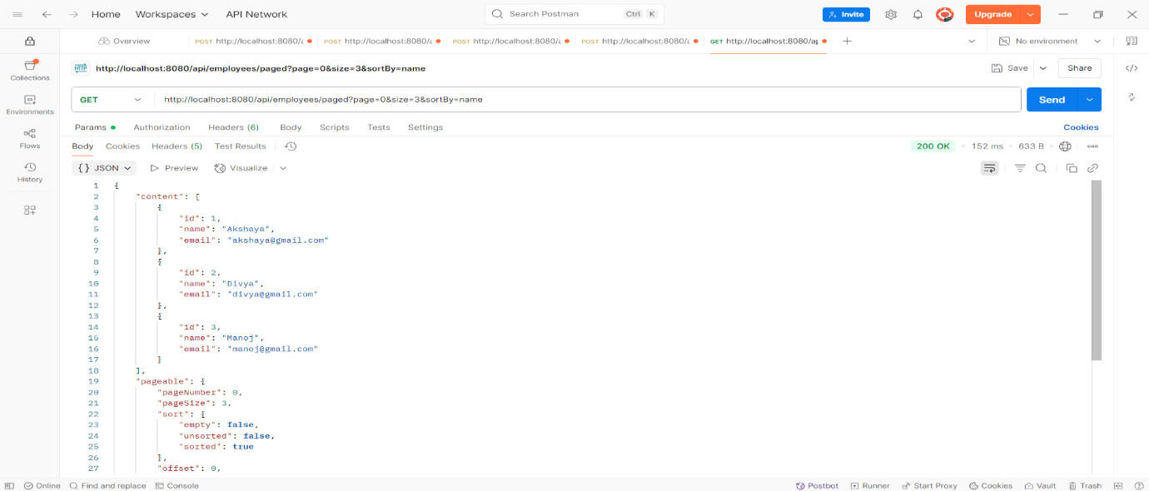

**Exercise 7: Employee Management System - Enabling Entity Auditing**

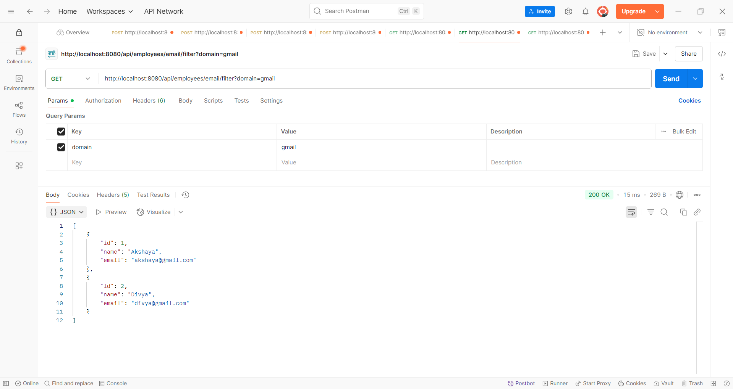

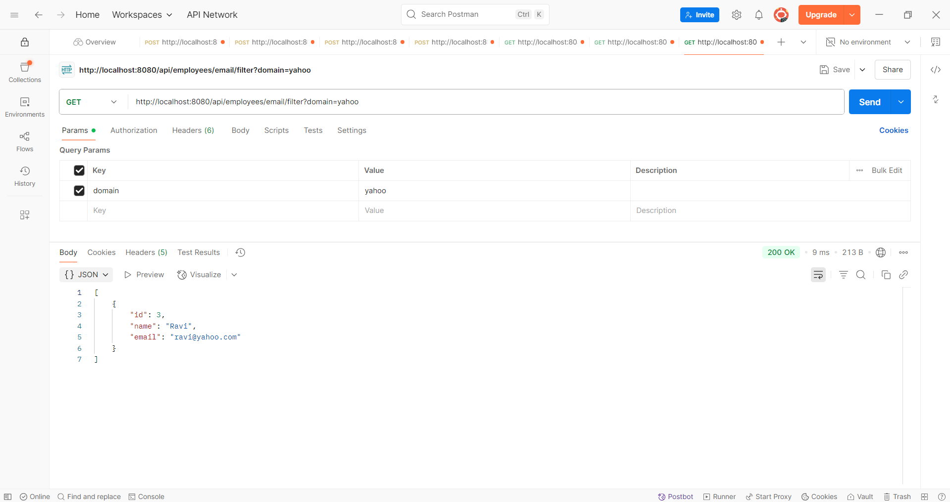

**Exercise 8: Employee Management System - Creating Projections**

